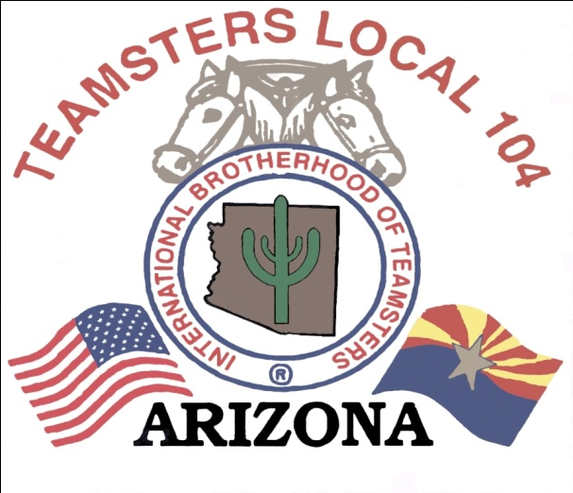
APRIL BARGAINING UPDATE 2013

Your IBT/CWA Association Negotiating Committee met this month in Tempe, during the period of April 16th thru the 18th.
On Tuesday, April 16th, we met with the company and gave them proposals for Article 18- Sick Leave, Article 32- Call Monitoring. The company gave us proposals on Article 6- Overtime, Article 7- Overtime Reservations and Article 34- General and Miscellaneous. We also gave the company a proposal for a Pension Plan. We advised the company that our members expressed a desire for an added pension plan to supplement their retirement. We wanted to make sure that our members had a guaranteed benefit that they could count on when they reach retirement age. We also advised the company that this pension plan would not be in the control of the company and that the union would be a partner in the oversight of the funds. We also reached a tentative agreement on Article 30- Safety and Health. We ended the day discussing counter proposals.
On Wednesday, April 17th, we continued to go over counter proposals and prepare for the following day.
On Thursday, April 18th, we gave the company a proposal on Article 36- Compensation. We gave the company a wage chart that would bring us an industry standard wage. We advised the company that we have earned record profits and should no longer be living on a wage with little increase from our 1999 contract rates. The company passed proposals on Article 18- Sick Leave, Article 24- Shift Definitions and Premiums and Article 32- Call Monitoring. We ended the session discussing future dates for negotiations.
Keep in mind we do not give specifics right now on each article because they can change in each session of bargaining and until we have a final tentative agreement to vote on, the proposed language can change often and we do not want to cause any confusion.
The next scheduled bargaining session is in Tempe, Arizona on June 4th, 5th, 6th, and 7th.

In Solidarity,
Kimberly Barboro
Business Agent US Airways
Teamsters Local 104

